

NATIONAL UNIVERSITY OF MODERN LANGUAGES

Artificial Intelligence Final Project

NAME: M Abdul Rafay
ROLL NO: FL23791
PROGRAM: BSSE (6th Semester)
COURSE: Artificial Intelligence
SUBMITTED TO: Mam Amna Sajjad

DATE: 5/15/2026 DAY: Friday
Table Of Contents
1. Introduction 1
2. Dataset Overview 1
3. Task 1: Dataset Loading and Exploration 2
3.1 First 20 Rows 2
3.2 Shape, Column Names, and Data Types 3
3.3 Missing Values 4
3.4 Summary Statistics 4
3.5 What This Dataset Is About 5
4. Task 2: Problem Type 5
5. Task 3: Data Preprocessing 6
5.1 Handling Missing Values 6
5.2 Encoding Categorical Columns 6
5.3 Feature and Target Separation 6
5.4 Train-Test Split 7
5.5 Feature Scaling 7
6. Task 4: Data Visualization 7
6.1 Correlation Heatmap 7
6.2 Boxplot 8
6.3 Histogram 9
6.4 Scatter Plot 9
6.5 Bar Chart 10
6.6 Pie Chart 11
7. Task 5: Machine Learning Algorithms 11
7.1 Logistic Regression 11
7.2 Random Forest Classifier 11
7.3 K-Nearest Neighbors (k = 7) 12
8. Task 6: Model Evaluation 12
8.1 Logistic Regression Results 12
8.2 Random Forest Results 13
8.3 K-Nearest Neighbors Results 14
9. Comparison of Models 15
10. Result Interpretation 15
10.1 Best Model 15
10.2 Observations from the Data 15
10.3 Three Insights from the Visualizations 16
10.4 Limitations and Possible Improvements 16
11. Conclusion 16
References 17
Appendix: Python Code 18

List of Figures
Figure 1: First 20 rows of the dataset — df.head(20) 3
Figure 2: df.dtypes output 3
Figure 3: df.info() output showing non-null counts for all columns 4
Figure 4: df.isnull().sum() — zero missing values in all columns 4
Figure 5: df.describe() — summary statistics for all numerical columns 5
Figure 6: Preprocessing confirmation — encoding output, split sizes, and scaling 7
Figure 7: Correlation Heatmap of all numerical features 7
Figure 9: Boxplot of Stress Level grouped by Depression Label 8
Figure 8: Histogram of Daily Social Media Hours 9
Figure 10: Scatter Plot of Sleep Hours vs Academic Performance 9
Figure 11: Bar Chart of Platform Usage 10
Figure 12: Pie Chart of Depression Label Distribution 11
Figure 13: Logistic Regression — Accuracy, F1 Score, and Classification Report 12
Figure 14: Confusion Matrix Heatmap — Logistic Regression 12
Figure 15: Full notebook running in Google Colab. all 16 cells executed 26

List of Tables
Table 1: Dataset Columns, Data Types, and Descriptions 1
Table 2: Comparison of Problem Types 6
Table 3: Model Comparison Summary 15

1. Introduction
This lab project applies machine learning techniques on the Teen Mental Health Dataset to predict whether a teenager is at risk of depression. The dataset contains 1,200 records and 13 features related to social media usage, sleep, stress, anxiety, academic performance, and physical activity.
The task is a binary classification problem because the target variable, depression_label, contains two classes: 0 (not at risk) and 1 (at risk). The project was implemented in Python using Google Colab. The workflow included dataset exploration, preprocessing, visualization, model training, and evaluation.

2. Dataset Overview
The dataset contains 1,200 rows and 13 columns with no missing values. Features include age, gender, daily social media usage, sleep hours, stress level, anxiety level, addiction level, and academic performance.
The target variable depression_label is highly imbalanced:
- Class 0 (Not Depressed): 1,169 samples (97.42%)
- Class 1 (Depressed): 31 samples (2.58%)
This imbalance affects model performance and evaluation.
Table 1: Dataset Columns, Data Types, and Descriptions
Column Name | Type | What it stores
age | int64 | Age of the student (13 to 19)
gender | object | Gender of the student — male or female
daily_social_media_hours | float64 | Hours per day spent on social media (1.0 to 8.0)
platform_usage | object | Which platform the student uses: Instagram, TikTok, or Both
sleep_hours | float64 | Average number of hours of sleep per night
screen_time_before_sleep | float64 | Hours of screen time immediately before sleeping
academic_performance | float64 | Academic score on a GPA-style scale from 2.0 to 4.0
physical_activity | float64 | Hours of physical activity per day (0.0 to 2.0)
social_interaction_level | object | How socially active the student is: low, medium, or high
stress_level | int64 | Self-reported stress score on a scale of 1 to 10
anxiety_level | int64 | Self-reported anxiety score on a scale of 1 to 10
addiction_level | int64 | Social media addiction score on a scale of 1 to 10
depression_label | int64 | Target variable — 0: not at risk, 1: at risk of depression

3. Task 1: Dataset Loading and Exploration

3.1 First 20 Rows
The dataset was loaded using pd.read_csv(). We then printed the first 20 rows with df.head(20) to check that the data loaded correctly and to get a general sense of what the values look like.
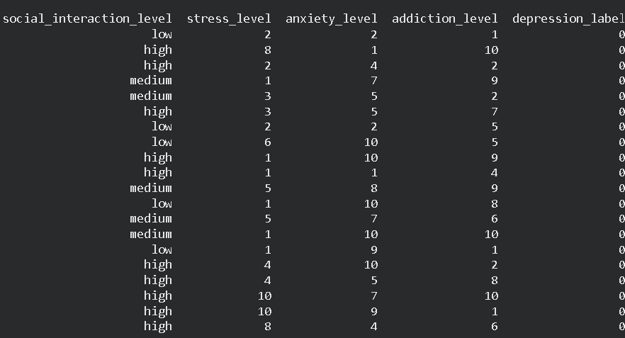
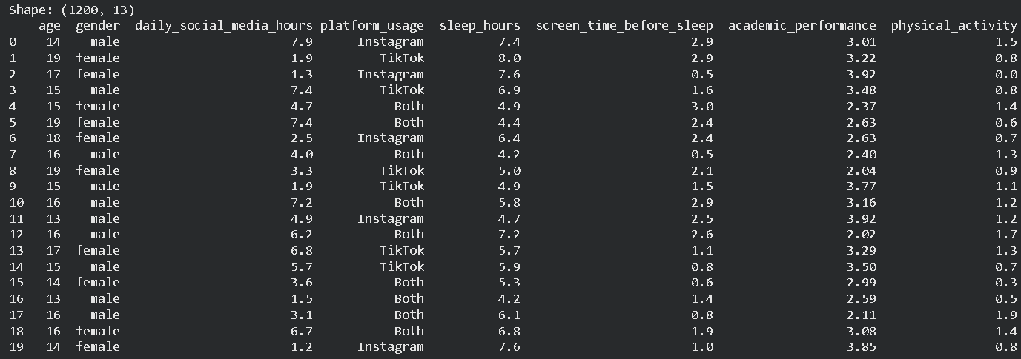
Figure 1: First 20 rows of the dataset — df.head(20)

3.2 Shape, Column Names, and Data Types
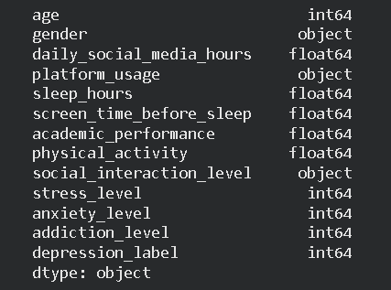
Running df.shape confirmed the dataset has 1,200 rows and 13 columns. We used df.dtypes to see the data type of each column and df.info() to check that all columns are fully populated with no null entries.
Figure 2: df.dtypes output
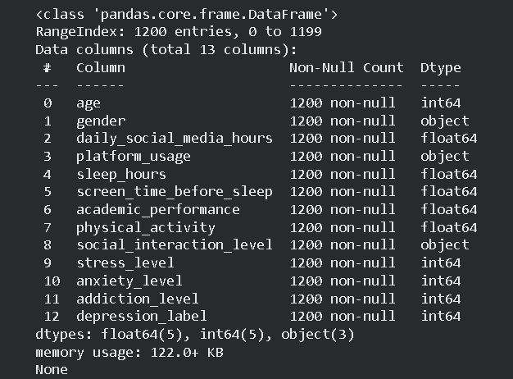
Figure 3: df.info() output showing non-null counts for all columns

3.3 Missing Values
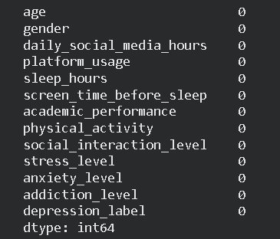
We ran df.isnull().sum() and the result was 0 for every single column. The dataset is complete and no filling or removal of rows was needed.
Figure 4: df.isnull().sum() — zero missing values in all columns

3.4 Summary Statistics
df.describe() showed:
- Average age: 15.93 years
- Average social media usage: 4.54 hours/day
- Average sleep: 6.45 hours
- Average stress level: 5.45
- Average anxiety level: 5.64
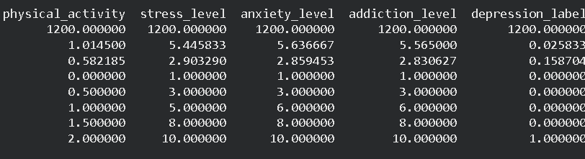
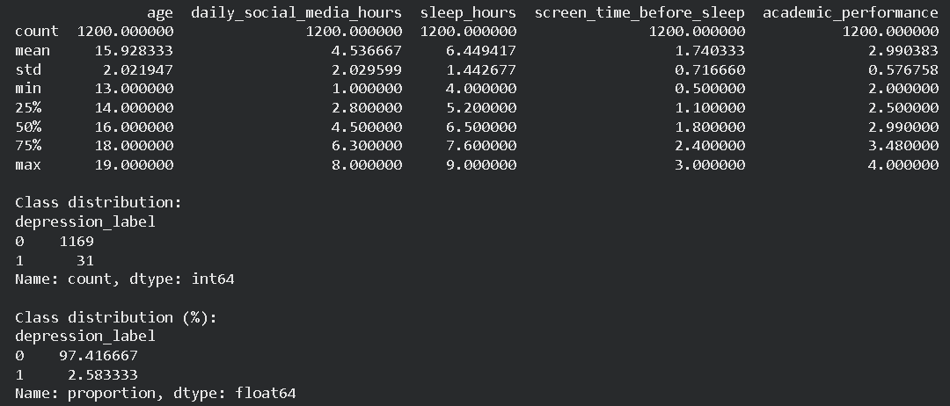
Figure 5: df.describe() — summary statistics for all numerical columns

3.5 What This Dataset Is About
This dataset was created to examine the relationship between teenage social media behaviour and mental health outcomes. Each row represents one student. Most of the scores such as stress, anxiety, and addiction are self-reported, meaning the values depend on how the student rated themselves. The target column depression_label is binary. Because 97.42% of the rows belong to class 0, a model that simply always predicts 0 would still achieve over 97% accuracy. This is why we also look at the weighted F1-score rather than relying on accuracy alone.

4. Task 2: Problem Type
Decision: Binary Classification
The column we are predicting, depression_label, has exactly two possible values: 0 and 1. This makes it a classification problem, not regression and not clustering.
We would choose regression if the target were a continuous number, such as predicting an actual anxiety score or a GPA value. We would choose clustering if there were no label column and we had to group the students ourselves based on their similarities. Neither applies here. The label already exists and it is categorical with two classes. Table 2 summarises this comparison.
Table 2: Comparison of Problem Types
Type | When to use | Applies here?
Classification | Target is a category or label | Yes depression_label is 0 or 1
Regression | Target is a continuous numerical value | No we are not predicting a number
Clustering | No label exists; data is grouped freely | No the label column already exists

5. Task 3: Data Preprocessing

5.1 Handling Missing Values
As confirmed in the exploration step, the dataset has no missing values anywhere. No imputation or row removal was necessary.

5.2 Encoding Categorical Columns
Categorical columns were converted into numeric form:
- Gender: female = 0, male = 1
- Social interaction: low = 0, medium = 1, high = 2
- Platform usage: Instagram = 0, TikTok = 1, Both = 2

5.3 Feature and Target Separation
After encoding, all 12 input columns were stored as the feature matrix X. The depression_label column was stored separately as y, the target variable we want to predict.

5.4 Train-Test Split
The data was split 80/20 using train_test_split() with random_state=42 and stratify=y. The stratify parameter makes sure the same class proportion (97.42% class 0 and 2.58% class 1) is maintained in both the training and test sets.
- Training set: 960 samples (25 depressed, 935 not depressed)
- Test set: 240 samples (6 depressed, 234 not depressed)

5.5 Feature Scaling
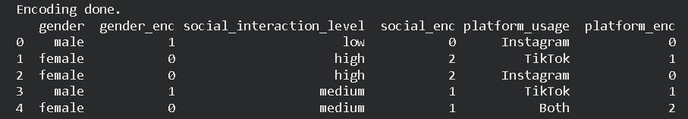
StandardScaler was applied for Logistic Regression and KNN because these algorithms depend on feature magnitude. Random Forest was trained on unscaled data.
Figure 6: Preprocessing confirmation — encoding output, split sizes, and scaling

6. Task 4: Data Visualization

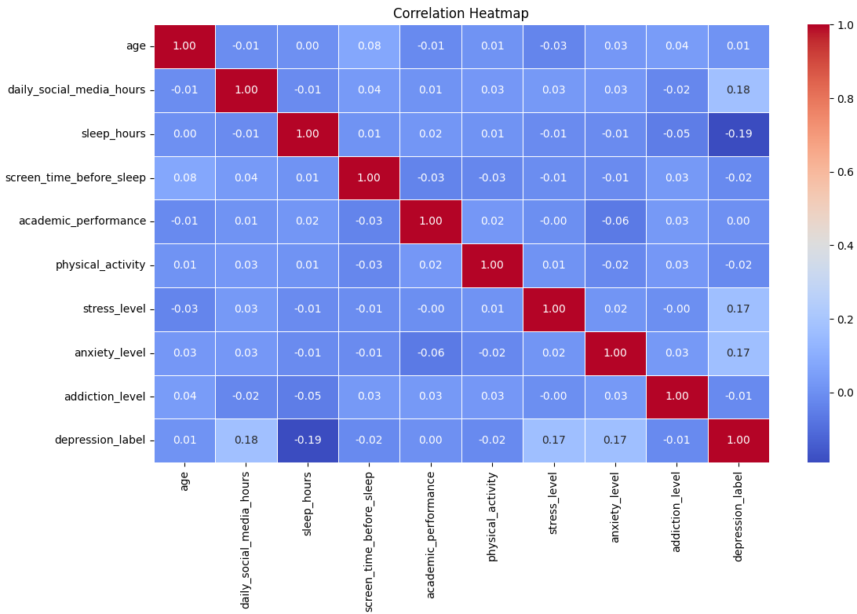
6.1 Correlation Heatmap
Figure 7: Correlation Heatmap of all numerical features

The heatmap shows the pairwise correlation between all numerical columns. The strongest positive correlation is between stress_level and anxiety_level, which makes sense as students who report high stress tend to also report high anxiety. Addiction level and daily social media hours are also positively linked. The correlation between individual features and the target column depression_label is generally low, meaning no single feature by itself is a strong predictor of depression in this dataset.

6.2 Boxplot
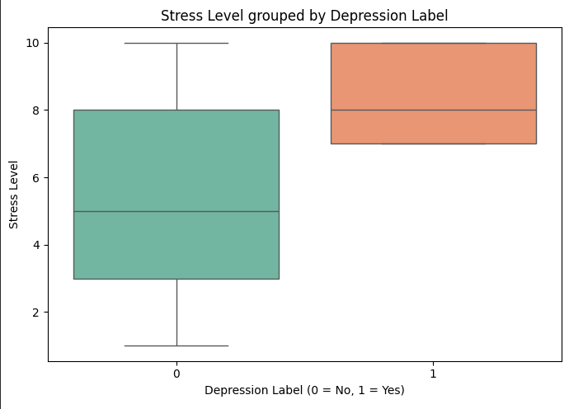
The boxplot compares the distribution of stress_level between the two groups. Students labelled as depressed (class 1) have a noticeably higher median stress level compared to students who are not depressed (class 0). The spread of values is also wider for the depressed group. Among all the features we visualized, stress level showed the clearest difference between the two classes.
Figure 9: Boxplot of Stress Level grouped by Depression Label

6.3 Histogram
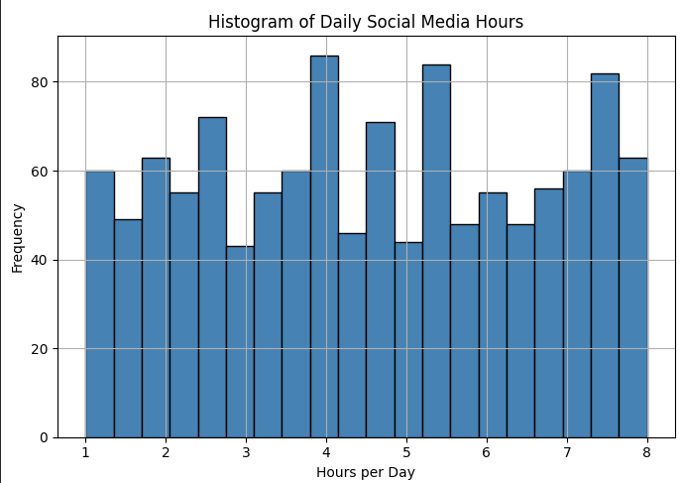
The distribution of daily social media hours is fairly even across the range of 1 to 8 hours. There is no strong peak at any one value. This tells us the dataset does not heavily favour light or heavy social media users and provides a good spread of usage patterns for the model to learn from.
Figure 8: Histogram of Daily Social Media Hours

6.4 Scatter Plot
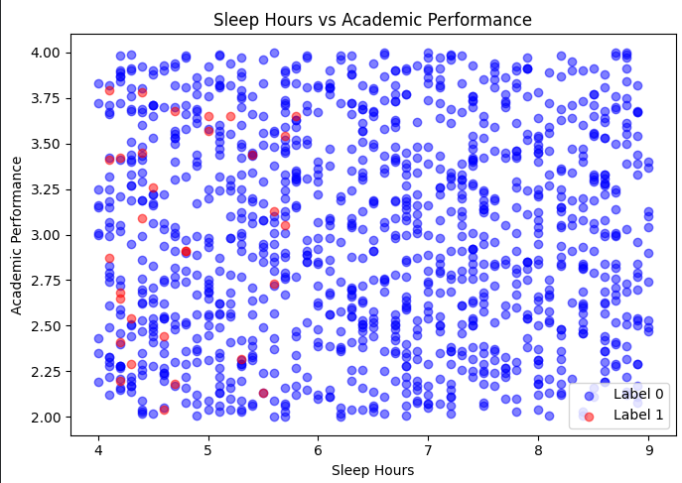
The scatter plot shows sleep hours on the x-axis and academic performance on the y-axis, with the two classes coloured differently. Students who sleep less than 5 hours appear slightly more toward the lower end of academic performance, but the trend is weak. More importantly, the depressed students (class 1) do not form a separate cluster anywhere on the plot. They are scattered throughout the same regions as non-depressed students, which is one reason why classification is so difficult on this dataset.
Figure 10: Scatter Plot of Sleep Hours vs Academic Performance

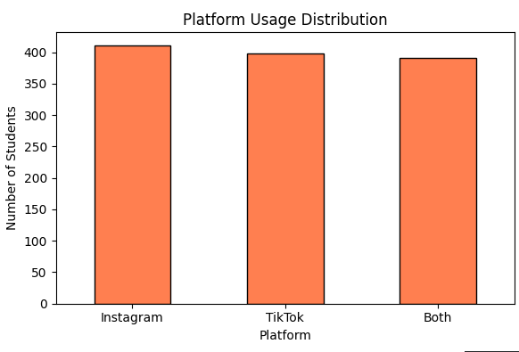
6.5 Bar Chart
Figure 11: Bar Chart of Platform Usage
The bar chart shows that the three platform categories have nearly equal representation: Instagram has 411 students, TikTok has 398, and Both has 391. This balanced distribution means platform usage is unlikely to introduce any bias into the model.

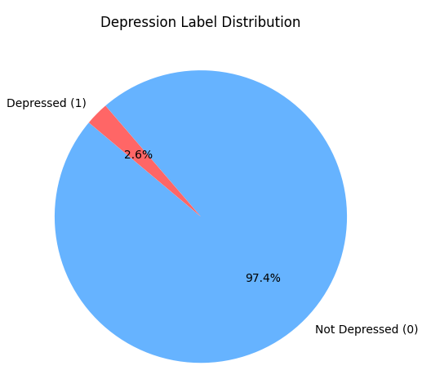
6.6 Pie Chart
Figure 12: Pie Chart of Depression Label Distribution
The pie chart clearly shows a severe class imbalance, with 97.42% of students not depressed and only 2.58% depressed. Because of this imbalance, a model that always predicts class 0 can still achieve over 97% accuracy without identifying any depressed students. This makes accuracy an unreliable evaluation metric for this dataset.

7. Task 5: Machine Learning Algorithms
Three classification algorithms were applied to the dataset.

7.1 Logistic Regression
Logistic Regression is a linear classification model that estimates the probability of a data point belonging to each class and then assigns the class with the higher probability. It is a standard starting point for binary classification and the results are straightforward to interpret. We set max_iter=1000 to ensure the solver converges properly given the number of features and the nature of the data. This model was trained on the scaled feature set.

7.2 Random Forest Classifier
Random Forest builds an ensemble of 100 decision trees, each trained on a random sample of the data, and combines their predictions by majority vote. It can capture non-linear relationships between features and is generally more robust to irrelevant features than a single decision tree. Since tree-based models split on value thresholds rather than distances, scaling is not required. We used n_estimators=100 and random_state=42, and trained the model on the original unscaled feature matrix.

7.3 K-Nearest Neighbors (k = 7)
KNN classifies a new data point by finding its k nearest neighbours in the training set and assigning whichever label the majority of those neighbours have. We chose k = 7 because using an odd number prevents tied votes and 7 is a reasonable default for a dataset of this size. KNN relies entirely on Euclidean distance between data points, so it requires scaled features. This model was trained on the scaled training set.

8. Task 6: Model Evaluation

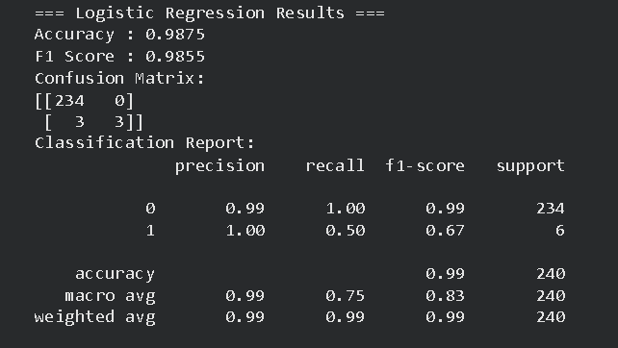
8.1 Logistic Regression Results
Figure 13: Logistic Regression — Accuracy, F1 Score, and Classification Report
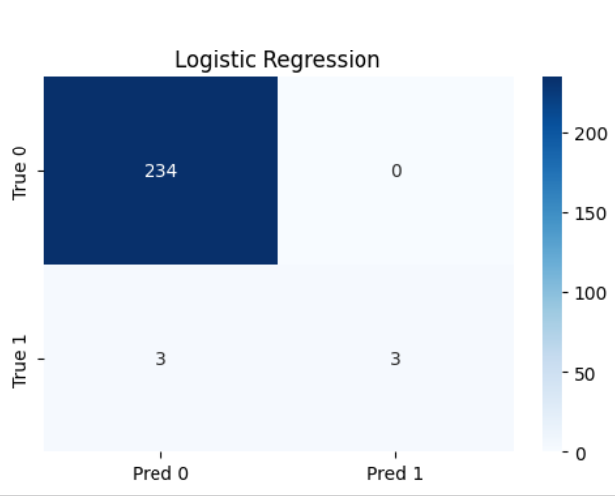
Figure 14: Confusion Matrix Heatmap — Logistic Regression
Logistic Regression achieved an accuracy of 98.75% and a weighted F1-score of 0.9855. The confusion matrix showed 234 true negatives, 0 false positives, 3 false negatives, and 3 true positives. This means it correctly identified 3 out of the 6 depressed students in the test set, giving a recall of 50% for class 1. It was the only model that detected any depressed students at all.

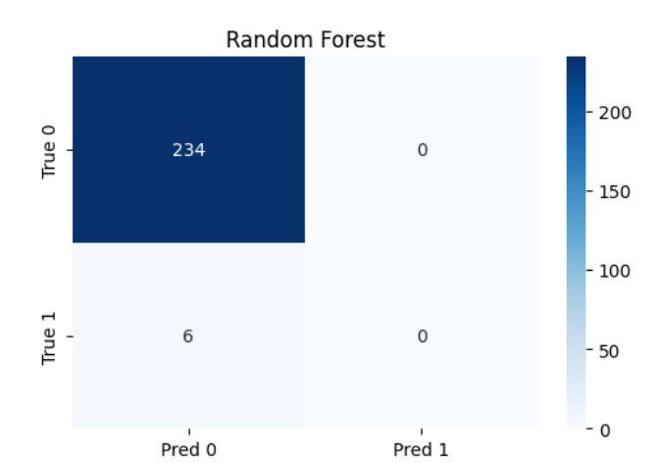
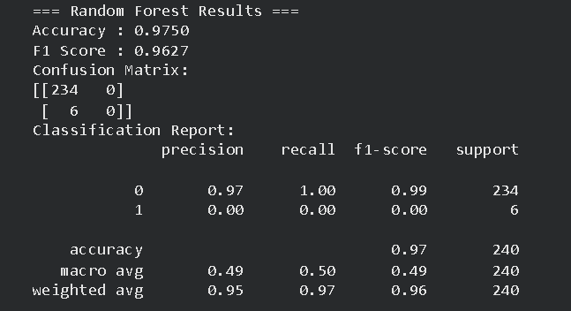
8.2 Random Forest Results
Figure 15: Confusion Matrix Heatmap — Random Forest
Figure 14: Random Forest — Accuracy, F1 Score, and Classification Report
Random Forest achieved an accuracy of 97.50% and a weighted F1-score of 0.9627. The confusion matrix showed 234 true negatives, 0 false positives, 6 false negatives, and 0 true positives. It predicted class 0 for every single test sample and did not detect any depressed student. The high accuracy comes purely from the class imbalance, not from the model learning anything useful about the minority class.

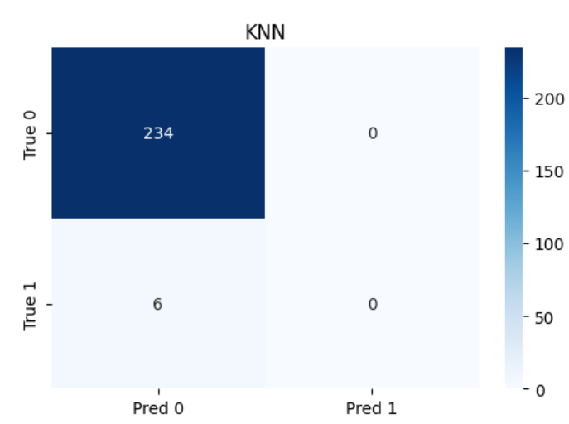
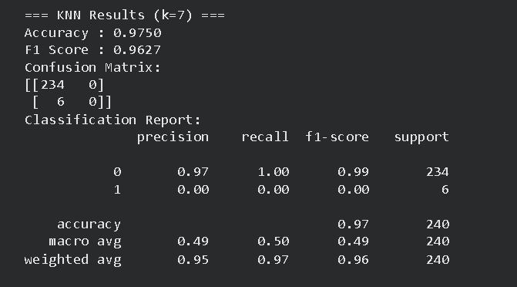
8.3 K-Nearest Neighbors Results
Figure 17: Confusion Matrix Heatmap. KNN
Figure 16: K-Nearest Neighbors. Accuracy, F1 Score, and Classification Report
KNN also achieved 97.50% accuracy and a weighted F1-score of 0.9627. Its confusion matrix was identical to Random Forest: 234 true negatives, 0 false positives, 6 false negatives, 0 true positives. When the training data has very few minority-class examples, the 7 nearest neighbours of any test point are almost always class 0, so the model ends up always predicting 0.

9. Comparison of Models
Table 3: Model Comparison Summary
Model | Accuracy | F1 (Weighted) | Comment
Logistic Regression | 98.75% | 0.9855 | Best overall correctly identified 3 out of 6 depressed students (recall 50%)
Random Forest | 97.50% | 0.9627 | Predicted class 0 for every test sample — zero depressed students detected
K-Nearest Neighbors | 97.50% | 0.9627 | Same outcome as Random Forest — no minority class detected

10. Result Interpretation

10.1 Best Model
Logistic Regression performed best in this experiment, correctly identifying 3 out of 6 depressed students. Unlike Random Forest and KNN, it was able to capture some minority-class patterns. This is because Logistic Regression learns a linear decision boundary in a scaled feature space, which can slightly favor minority class detection. In contrast, tree-based and distance-based models tend to bias toward the majority class (97.42%), especially under severe class imbalance.

10.2 Observations from the Data
The dataset was clean and required minimal preprocessing. The main challenge was extreme class imbalance, with only 31 depressed samples out of 1,200. As a result, Random Forest and KNN failed to detect any depressed cases despite achieving 97.50% accuracy, showing that accuracy is misleading in this context. A weighted F1-score provides a more realistic evaluation of model performance on imbalanced data.

10.3 Three Insights from the Visualizations
- The correlation heatmap shows that stress level and anxiety level are the most strongly related features. Both also have a weak positive relationship with the depression label, but overall correlations are low.
- The boxplot of stress level shows a clear difference between classes. Depressed students have higher median stress and greater variability, making stress the most distinguishing feature.
- The scatter plot of sleep hours vs academic performance shows heavy overlap between both classes. There is no clear separation, which explains why even Logistic Regression only detected half of the depressed cases.

10.4 Limitations and Possible Improvements
The main limitation is severe class imbalance in the dataset. To improve performance, techniques such as class weighting in Logistic Regression, SMOTE oversampling, or collecting more minority-class data could be used. Advanced models like XGBoost with scale_pos_weight could also help handle imbalance more effectively.

11. Conclusion
This project covered a full machine learning workflow using the Teen Mental Health Dataset, including data exploration, visualization, preprocessing, model training, and evaluation.
The key takeaway is that accuracy alone is misleading in imbalanced datasets. Although Random Forest and KNN achieved 97.50% accuracy, they failed to identify any depressed students. Logistic Regression performed better by detecting 3 out of 6 cases, showing that evaluation metrics like F1-score and recall are more meaningful for this type of problem.
Project Source Code (GitHub Repository:
GitHub:https://github.com/git-rafaykhan/university-resources/tree/17a5316ce1ff6fb49d201b27b37a511cd6604625/sem6/ai/project

References
- Teen Mental Health Dataset
- Scikit-learn: Machine Learning in Python
- Data Structures for Statistical Computing in Python
- Seaborn: Statistical Data Visualization
- Matplotlib: A 2D Graphics Environment

Appendix: Python Code
The complete code was written across 16 cells in Google Colab. Each cell is shown below in the order it was run.

Block 1 — Import Libraries

import pandas as pd
import numpy as np
import matplotlib.pyplot as plt
import seaborn as sns
from sklearn.model_selection import train_test_split
from sklearn.preprocessing import StandardScaler, LabelEncoder
from sklearn.linear_model import LogisticRegression
from sklearn.ensemble import RandomForestClassifier
from sklearn.neighbors import KNeighborsClassifier
from sklearn.metrics import (accuracy_score, f1_score,
confusion_matrix, classification_report)
import warnings
warnings.filterwarnings('ignore')
Block 2 — Load Dataset

df = pd.read_csv('Teen_Mental_Health_Dataset.csv')
print('Shape:', df.shape)
print(df.head(20))
Block 3 — Column Data Types

print(df.dtypes)

Block 4 — Dataset Info

print(df.info())
Block 5 — Missing Values Check

print(df.isnull().sum())
Block 6 — Summary Statistics

print(df.describe())
Block 7 — All Six Visualizations

# --- Figure 1: Correlation Heatmap ---
plt.figure(figsize=(12, 8))
sns.heatmap(df.corr(numeric_only=True), annot=True, fmt='.2f',
cmap='coolwarm', linewidths=0.5)
plt.title('Correlation Heatmap')
plt.tight_layout()
plt.show()

# --- Figure 2: Boxplot - Stress Level by Depression Label ---
plt.figure(figsize=(7, 5))
sns.boxplot(x='depression_label', y='stress_level', data=df, palette='Set2')
plt.title('Stress Level by Depression Label')
plt.xlabel('Depression Label (0 = Not at Risk, 1 = At Risk)')
plt.ylabel('Stress Level')
plt.tight_layout()
plt.show()

# --- Figure 3: Histogram - Daily Social Media Hours ---
plt.figure(figsize=(7, 5))
df['daily_social_media_hours'].hist(bins=20, color='steelblue', edgecolor='black')
plt.title('Distribution of Daily Social Media Hours')
plt.xlabel('Hours per Day')
plt.ylabel('Number of Students')
plt.tight_layout()
plt.show()

# --- Figure 4: Scatter Plot - Sleep Hours vs Academic Performance ---
plt.figure(figsize=(7, 5))
for label, colour in zip([0, 1], ['steelblue', 'red']):
subset = df[df['depression_label'] == label]
plt.scatter(subset['sleep_hours'], subset['academic_performance'],
label=f'Label {label}', alpha=0.5, color=colour)
plt.title('Sleep Hours vs Academic Performance')
plt.xlabel('Sleep Hours')
plt.ylabel('Academic Performance')
plt.legend()
plt.tight_layout()
plt.show()

# --- Figure 5: Bar Chart - Platform Usage ---
plt.figure(figsize=(6, 4))
df['platform_usage'].value_counts().plot(kind='bar',
color='coral', edgecolor='black')
plt.title('Platform Usage Distribution')
plt.xlabel('Platform')
plt.ylabel('Number of Students')
plt.xticks(rotation=0)
plt.tight_layout()
plt.show()

# --- Figure 6: Pie Chart - Depression Label Distribution ---
plt.figure(figsize=(6, 5))
counts = df['depression_label'].value_counts()
plt.pie(counts, labels=['Not at Risk (0)', 'At Risk (1)'],
autopct='%1.1f%%', startangle=140,
colors=['#66b3ff', '#ff6666'])
plt.title('Depression Label Distribution')
plt.tight_layout()
plt.show()
Block 8 — Encoding Categorical Columns

le = LabelEncoder()
df['gender_enc'] = le.fit_transform(df['gender'])
df['social_enc'] = df['social_interaction_level'].map(
{'low': 0, 'medium': 1, 'high': 2})
df['platform_enc'] = df['platform_usage'].map(
{'Instagram': 0, 'TikTok': 1, 'Both': 2})

print('Encoding complete.')
print(df[['gender','gender_enc','social_interaction_level',
'social_enc','platform_usage','platform_enc']].head(5))
Block 9 — Feature and Target Separation

feature_cols = ['age', 'gender_enc', 'daily_social_media_hours',
'platform_enc', 'sleep_hours', 'screen_time_before_sleep',
'academic_performance', 'physical_activity', 'social_enc',
'stress_level', 'anxiety_level', 'addiction_level']

X = df[feature_cols]
y = df['depression_label']

print('Feature matrix shape:', X.shape)
print('Target shape:', y.shape)
print('Class distribution in y:')
print(y.value_counts())
Block 10 — Train-Test Split (80/20, stratified)

X_train, X_test, y_train, y_test = train_test_split(
X, y, test_size=0.20, random_state=42, stratify=y)

print('Training set size:', X_train.shape)
print('Test set size: ', X_test.shape)
print('Class distribution in training set:')
print(y_train.value_counts())
print('Class distribution in test set:')
print(y_test.value_counts())
Block 11 — Feature Scaling with StandardScaler

scaler = StandardScaler()
X_train_sc = scaler.fit_transform(X_train)
X_test_sc = scaler.transform(X_test)

print('Scaling complete.')
print('Mean of scaled training features (should be ~0):')
print(X_train_sc.mean(axis=0).round(4))
Block 12 — Logistic Regression Training and Evaluation

lr_model = LogisticRegression(max_iter=1000, random_state=42)
lr_model.fit(X_train_sc, y_train)
y_pred_lr = lr_model.predict(X_test_sc)

print('=== Logistic Regression Results ===')
print(f'Accuracy : {accuracy_score(y_test, y_pred_lr):.4f}')
print(f'F1 Score : {f1_score(y_test, y_pred_lr,
average="weighted", zero_division=0):.4f}')
print()
print('Confusion Matrix:')
print(confusion_matrix(y_test, y_pred_lr))
print()
print('Classification Report:')
print(classification_report(y_test, y_pred_lr, zero_division=0))
Block 13 — Random Forest Training and Evaluation

rf_model = RandomForestClassifier(n_estimators=100, random_state=42)
rf_model.fit(X_train, y_train)
y_pred_rf = rf_model.predict(X_test)

print('=== Random Forest Results ===')
print(f'Accuracy : {accuracy_score(y_test, y_pred_rf):.4f}')
print(f'F1 Score : {f1_score(y_test, y_pred_rf,
average="weighted", zero_division=0):.4f}')
print()
print('Confusion Matrix:')
print(confusion_matrix(y_test, y_pred_rf))
print()
print('Classification Report:')
print(classification_report(y_test, y_pred_rf, zero_division=0))

Block 14 — K-Nearest Neighbors Training and Evaluation

knn_model = KNeighborsClassifier(n_neighbors=7)
knn_model.fit(X_train_sc, y_train)
y_pred_knn = knn_model.predict(X_test_sc)

print('=== K-Nearest Neighbors (k=7) Results ===')
print(f'Accuracy : {accuracy_score(y_test, y_pred_knn):.4f}')
print(f'F1 Score : {f1_score(y_test, y_pred_knn,
average="weighted", zero_division=0):.4f}')
print()
print('Confusion Matrix:')
print(confusion_matrix(y_test, y_pred_knn))
print()
print('Classification Report:')
print(classification_report(y_test, y_pred_knn, zero_division=0))
Block 15 — Confusion Matrix Heatmaps for All Three Models

fig, axes = plt.subplots(1, 3, figsize=(15, 4))

models_results = [
('Logistic Regression', y_pred_lr),
('Random Forest', y_pred_rf),
('KNN (k=7)', y_pred_knn),
]

for ax, (name, preds) in zip(axes, models_results):
cm = confusion_matrix(y_test, preds)
sns.heatmap(cm, annot=True, fmt='d', cmap='Blues', ax=ax,
xticklabels=['Predicted 0', 'Predicted 1'],
yticklabels=['Actual 0', 'Actual 1'])
ax.set_title(name)

plt.suptitle('Confusion Matrices for All Three Models', fontsize=13)
plt.tight_layout()
plt.show()
Block 16 — Final Model Comparison Summary

results = {
'Model': ['Logistic Regression', 'Random Forest', 'KNN (k=7)'],
'Accuracy': [
accuracy_score(y_test, y_pred_lr),
accuracy_score(y_test, y_pred_rf),
accuracy_score(y_test, y_pred_knn),
],
'F1 Score (Weighted)': [
f1_score(y_test, y_pred_lr, average='weighted', zero_division=0),
f1_score(y_test, y_pred_rf, average='weighted', zero_division=0),
f1_score(y_test, y_pred_knn, average='weighted', zero_division=0),
],
}

summary = pd.DataFrame(results)
summary['Accuracy'] = summary['Accuracy'].apply(lambda x: f'{x:.4f}')
summary['F1 Score (Weighted)'] = summary['F1 Score (Weighted)'].apply(lambda x: f'{x:.4f}')
print('=== Model Comparison Summary ===')
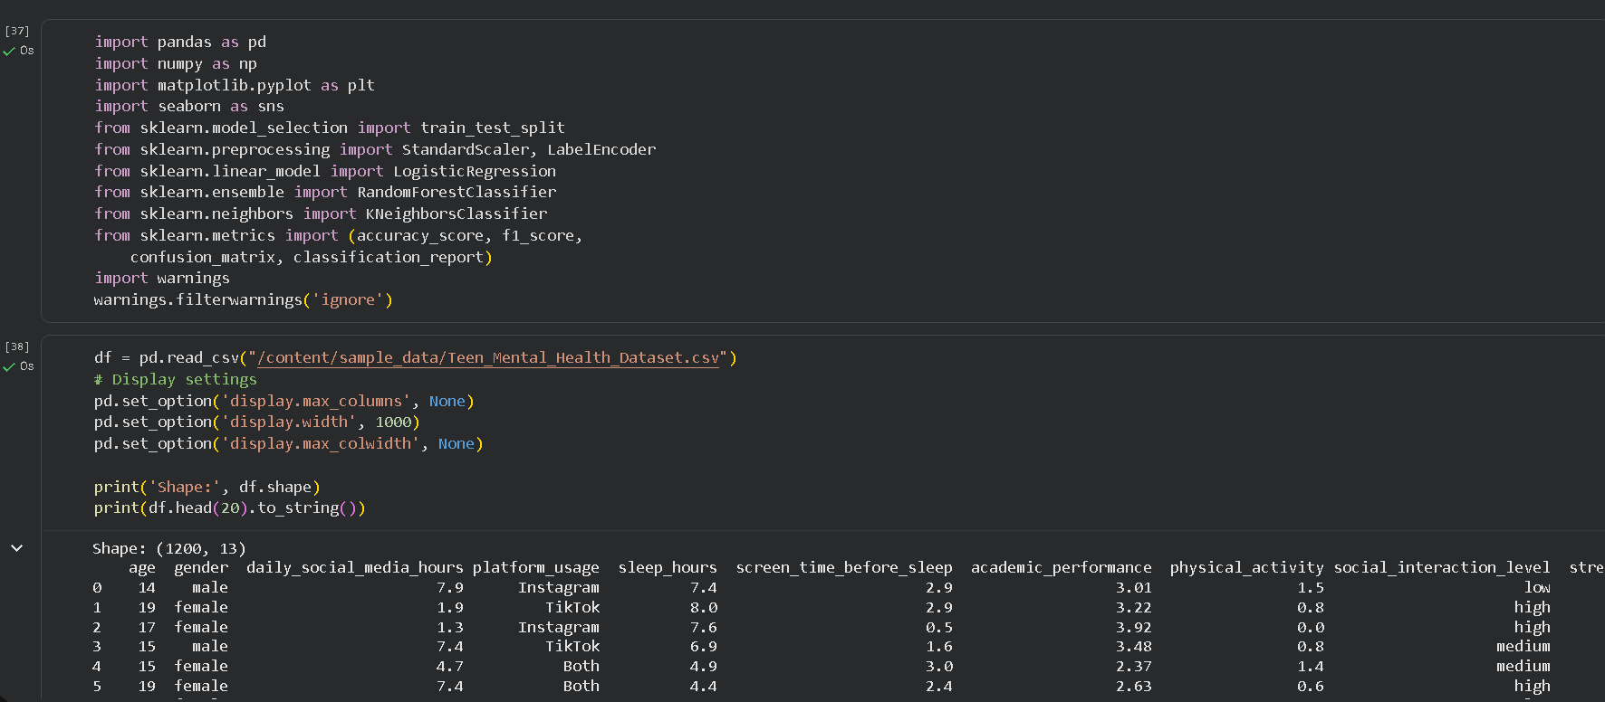
print(summary.to_string(index=False))
Figure 15: Full notebook running in Google Colab. all 16 cells executed

